Console.dir

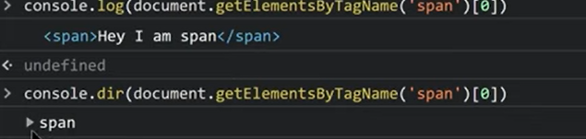

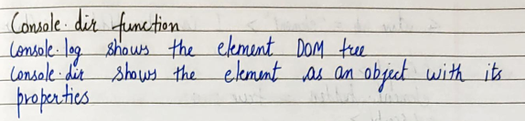

//console.log prints the whole element as Dom tree

And console.dir prints the element as a js object

Tag Name, Node name

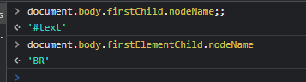

//difference

for finding the tagName use "Element" between the command like firstElementChild.nodeName;

and for node name simply just use firstChild.nodeName;

INNER HTML AND OUTER HTML

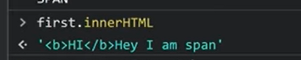

//first is the id of the span



//and this will print in the html page containing the “#first “ id



### Example

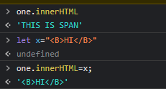

//HI in bold will be shown in html;

Another way of typing this is;

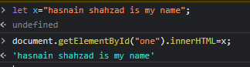

### DIFFERENCE BETWEEN INNER HTML AND OUTER HTML

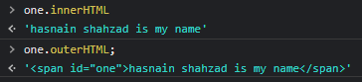

Another difference to notice the effect of inner and outer html

#### innerHTML

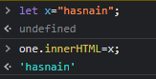



//this is span changes to hasnain;

#### But in case of outerHTML





//the whole element changes to the “x’ whatever was present in the x;

## TO BETTER UNDERSTAND THIS

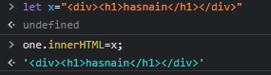 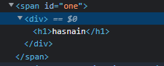

 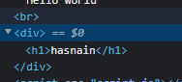

//outerHTML CHANGES THE WHOLE ELEMENT IN THE HTML DOC PAGE AS WELL AND WHEN IT PRINTS IT PRINTS THE WHOLE ELEMENT WITH TAGS ASWELL AND INNERHTML ADDS THE GIVEN VALUE IN THE ELEMENT TAG, as the name tells inner so it inserts in the existing element tag, AND INNER HTML ONLY PRINTS OUT WHAT IS PRESENT IN THE TAG

# NODE VALUE OR DATA

For text and comments use nodeValue or data

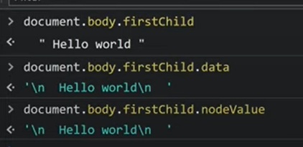

# Text content

//only tells the text content of the whole element and the children as well

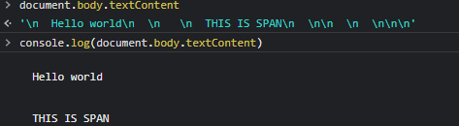

# The hidden property

3

If there is a hidden attribute in an html element simply add .hidden to show that!



// you can also hide an element using this